Documentation

# Objectives:

* Familiarize with Databases using Visual Studio and C#

# Exercises

**Exercise 1**

* The first exercise shows how to make some basic operations using databases.
* Each operation with its corresponding piece of code is show bellow:

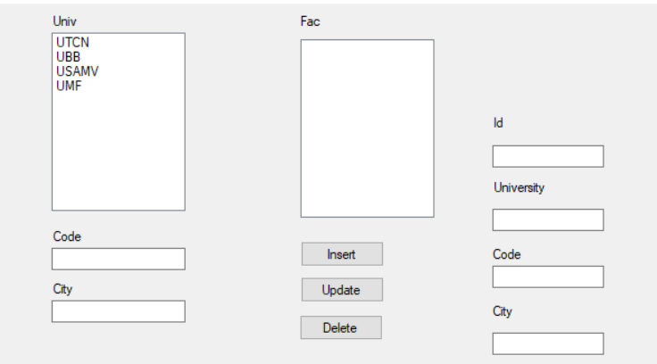

Fig. 1 The Database Before The addition Operation

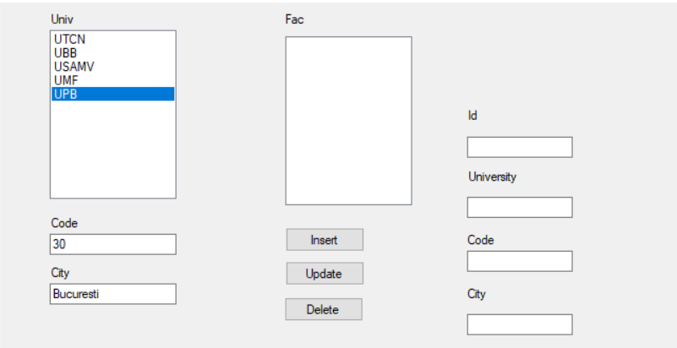

Fig. 2 The Database after inserted the “UPB” University from Bucharest

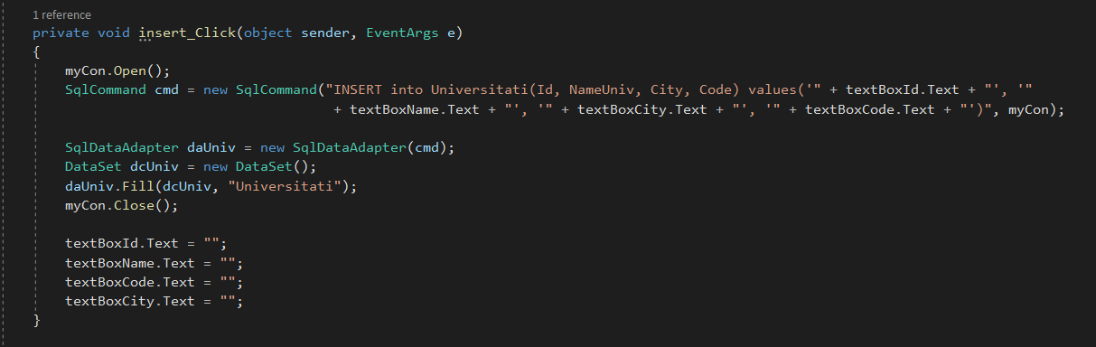

Fig. 3 Code for the Insert operation

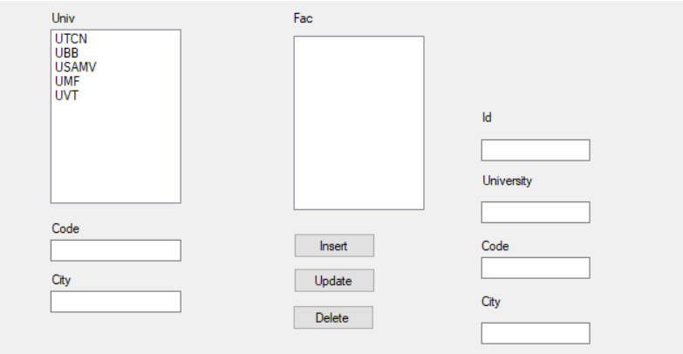

Fig. 4 The database after the “UPB” University was deleted

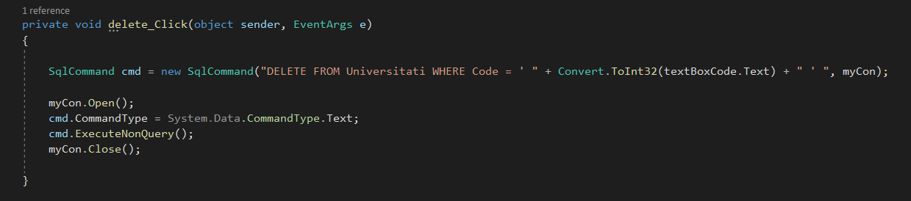

Fig. 5 Code for Delete Operation

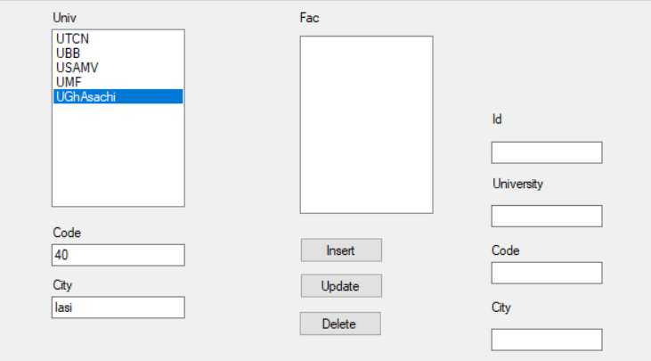

Fig. 6 The database after “UVT” was replaced with “UGhAsachi” from Iasi

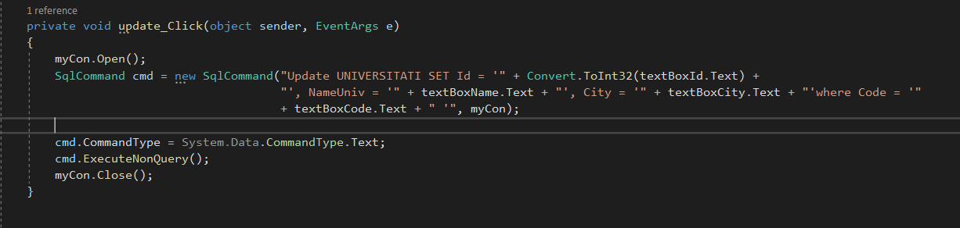

Fig. 7 Code for Update Operation

**Exercise 2**

* The second exercise is somehow similar with the first one
* We are using the “Faculties” Table and the operations are made using a dataGridView
* The figures below exemplifies these operations.

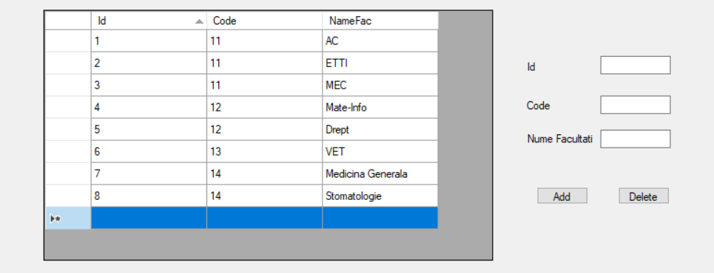

Fig. 8 The Faculty Table before adding anything

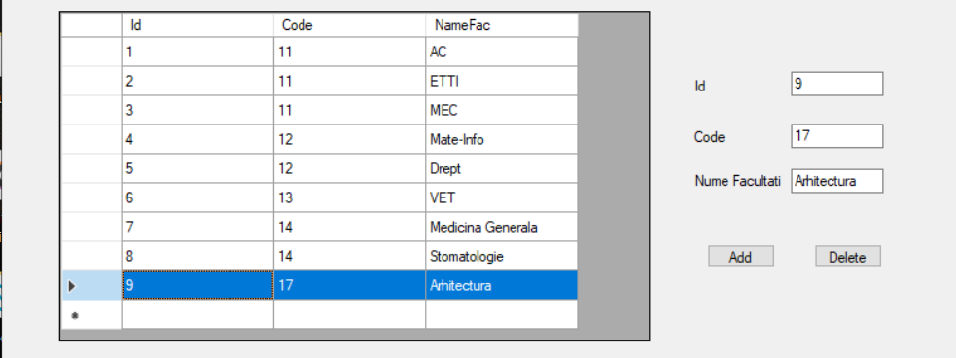

Fig. 9 The Faculty Table After adding the “Arhitectura” Faculty

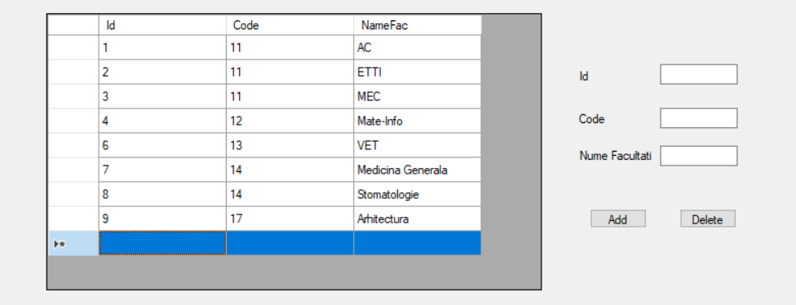

Fig. 10 The Facuty Table after deleting “Drept” Faculty